Abhishek Ojha

Seat No 027

practical no 5

Temporal Database

**Practical No: 5**

**Aim:** Create a temporal database and issue queries on it.

**Software Requirement:**

MongoDB.

**Query:**

1. Show the Employee Whose Record Date is 08-Mar-1987.
2. Show the Employee Whose Retired Date is 22-Mar-2021 .
3. Create a new table named as tbl_shares1.
4. Insert Some Row in Table tbl_shares1.
5. Display all the records you have entered in table.
6. Display records where price>100 and TransTime='01:09'.
7. Display the records where price=(select max(price) from tbl_shares1 where TransTime='02:04');.

**Practical Implementation:**

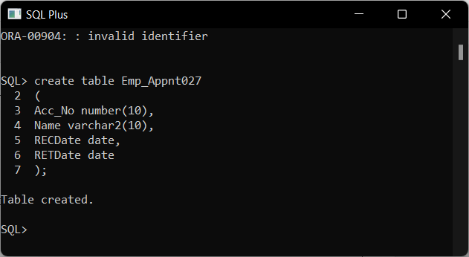

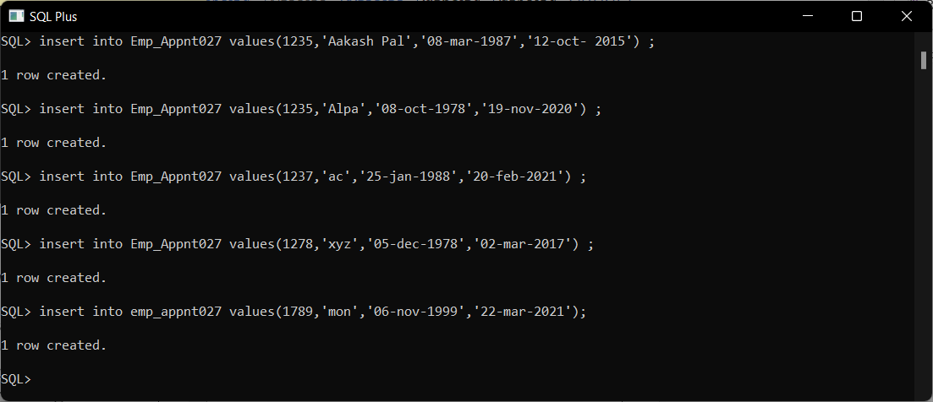

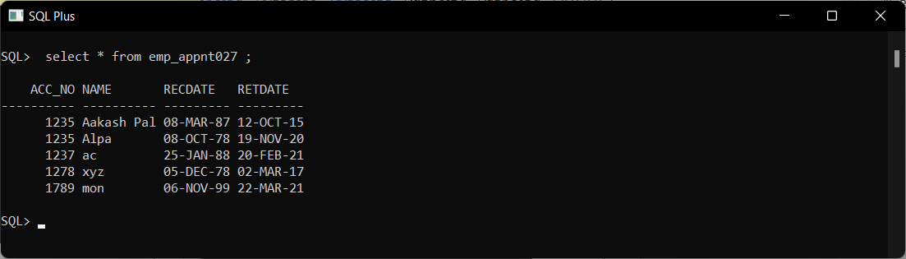

1. **Show the Employee Whose Record Date is 08-Mar-1987.**

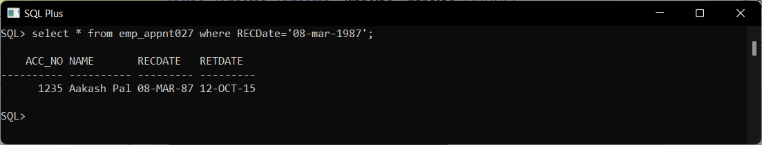

1. **Show the Employee Whose Retired Date is 22-Mar-2021.**

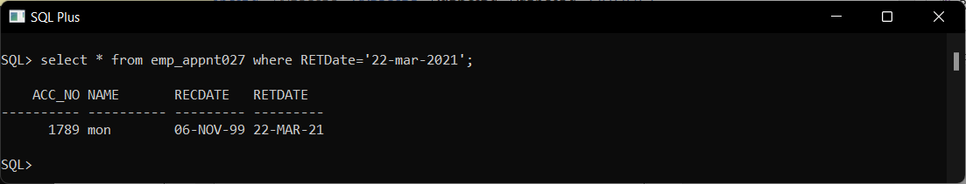

1. **Create a new table named as tbl_shares1.**

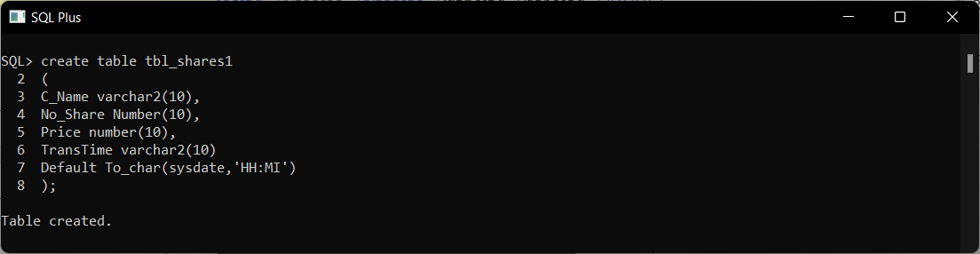

1. **Insert Some Row in Table tbl_shares1.**

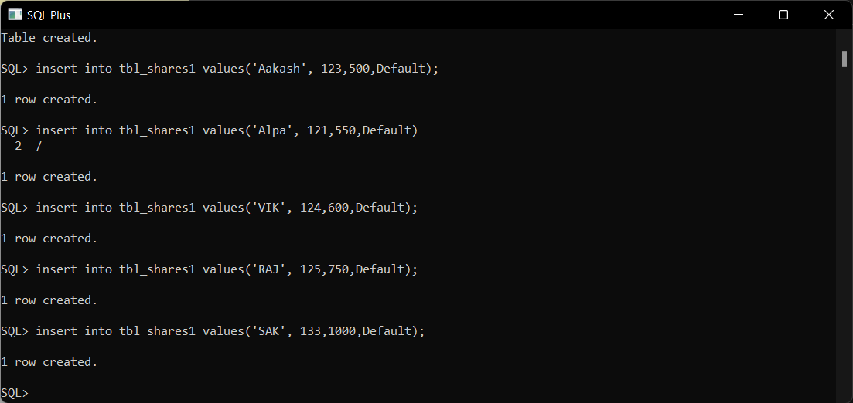

1. **Display all the records you have entered in table.**

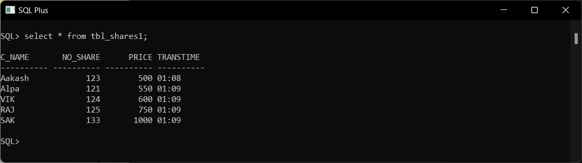

1. **Display records where price>100 and TransTime='01:09'.**

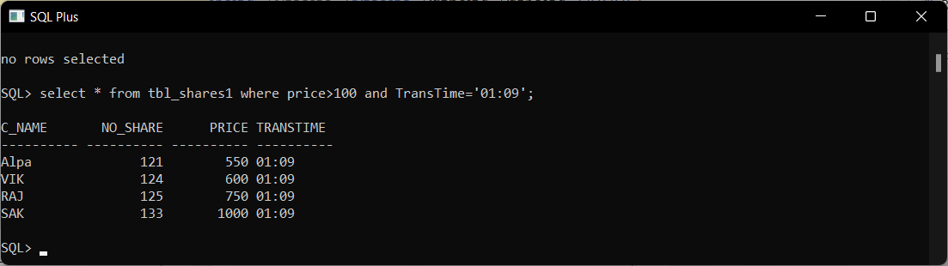

1. **Display the records where price=(select max(price) from tbl_shares1 where TransTime='02:04');**

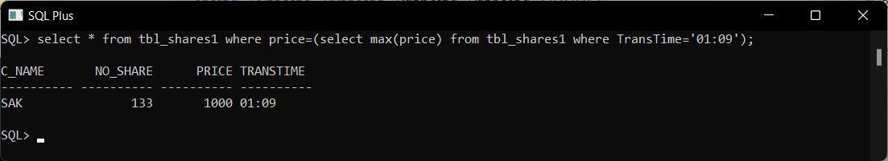

**Conclusion :** Successfully Performed and Implemented the temporal database and issue queries on Oracle Database.